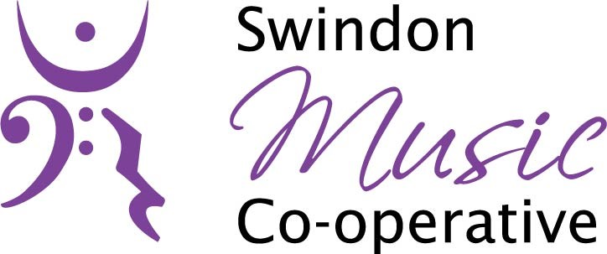

Online safety Agreement
Swindon Music Co-Operative understands the importance of children being able to use the internet for education and personal development. This includes social media platforms, games and apps. We aim to support children and young people in making use of these in our work. However, we also recognise that safeguards need to be in place to ensure children are always kept safe.
This agreement is part of our overarching code of behaviour for children and young people and staff and members. It also fits with our overarching online safety policy. If you would like to know more about this, please speak to Sharon Cullum, Safeguarding Lead for Swindon Music Co-Operative.
Parents/carers: Please read and discuss this agreement with your child and then sign it and also ask your child to sign it.
- Please ensure a suitable space is provided for the lesson. A quiet but communal area is ideal. Bedrooms must not be used for lessons.
- Please ensure that no personal or sensitive data is visible in the background.
Young person: Please read the following agreement and discuss it with your parents/carer.
- I will be responsible for my behaviour during lessons. This includes the resources I access and the language I use.
- I will not deliberately browse, download or upload material that could be considered offensive or illegal. If I accidentally come across any such material, I will report it immediately to the teacher.
- I will not send anyone material that could be considered threatening, bullying, offensive or illegal.
- I will not arrange a face-to-face meeting with the teacher unless I have discussed this with my parents and am accompanied by a trusted adult.
- I will be suitably dressed for my lesson (no pyjamas!)
- If I am concerned or upset about anything I see on the internet or any messages that I receive, I know I can talk to my parent/carer and Safeguarding lead at Swindon Music Co-Operative.
- I understand that these rules are designed to keep me safe and that if I choose not to follow them, Swindon Music Co-Operative will contact my parents/carers.
Signatures:
We have discussed this online safety agreement and [child’s name] agrees to follow the rules set out above.
Parent/carer signature………………….………………….……………
Date ………………………………………………
Young person’s signature……………………...........................
Date ……………………………………………...

